GIS Assignment 3 - The Happy Valley Ski Area

Student Name: Ronan Dillon

Student Number: C12355251

Question 1

**Happy Valley Ski Area Relief Map**

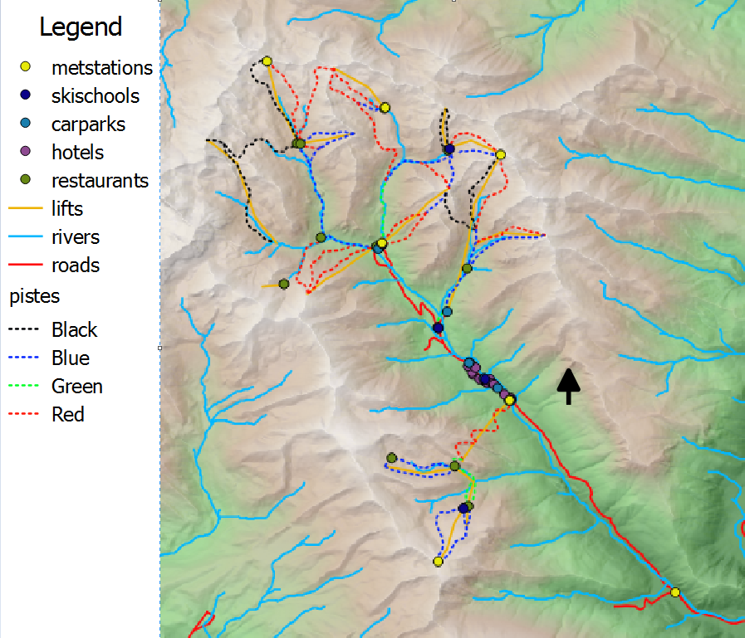

The relief map of the Happy Valley Area shows the relief in the area. The map contains all of the key elements of infrastructure from roads to hotels.

Question 2

**Mean Annual Snow Depth Map**

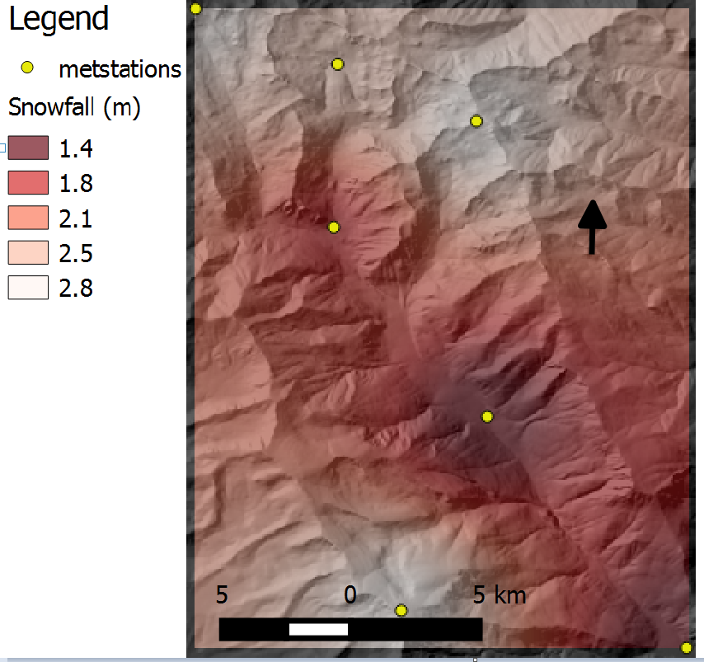

This mean snowfall map shows the average snowfall in metres using data collected by the seven meteorological stations in the Happy Valley Ski Area. Using interpolation I created a grid which shows estimates for the average snowfall in areas in the rest of the Happy Valley Area.

Question 3

**Avalanche Susceptible Areas Map**

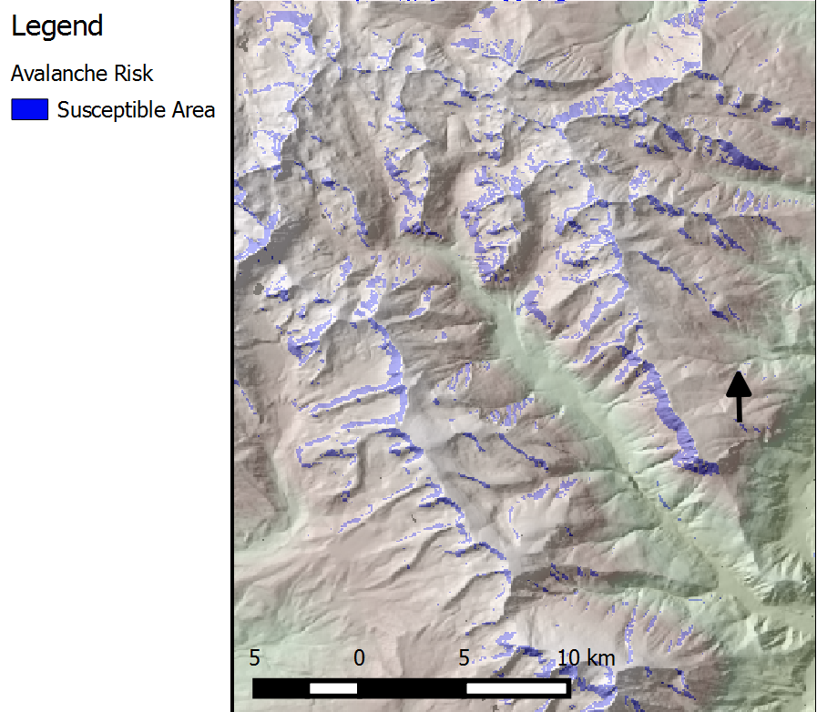

This map shows areas in the Happy Valley Ski Area which are susceptible to having an avalanche. An area was deemed to be at susceptible risk of an avalanche if the area had a slope between 20 and 45 degrees, if it was west facing and if the area was not forested.

**Avalanche Susceptible Areas Close To The Town Of Happy Valley Map**

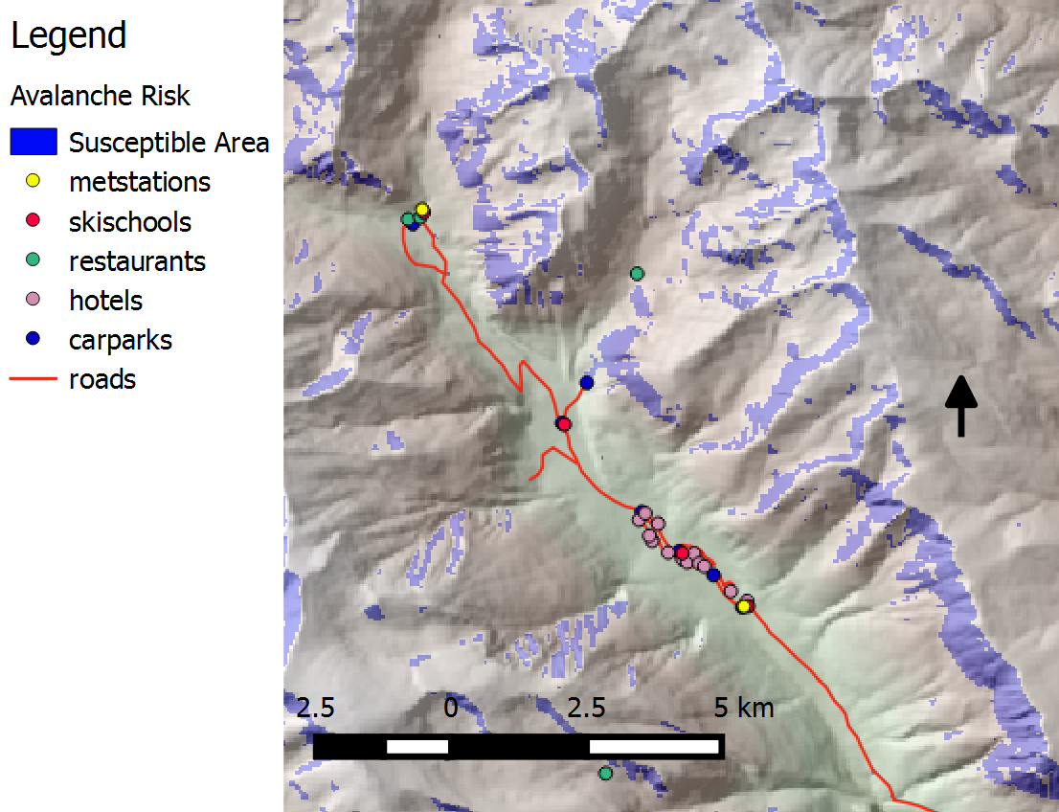

In this map I took a closer look at the town in Happy Valley and the areas around it which have been deemed to be at a susceptible risk of an avalanche. As can be seen from the map there are areas at risk of an avalanche which are considerably close to the town in Happy Valley which contains numerous hotels.

Question 4

**Optimal Areas For A New Meteorological Station Map**

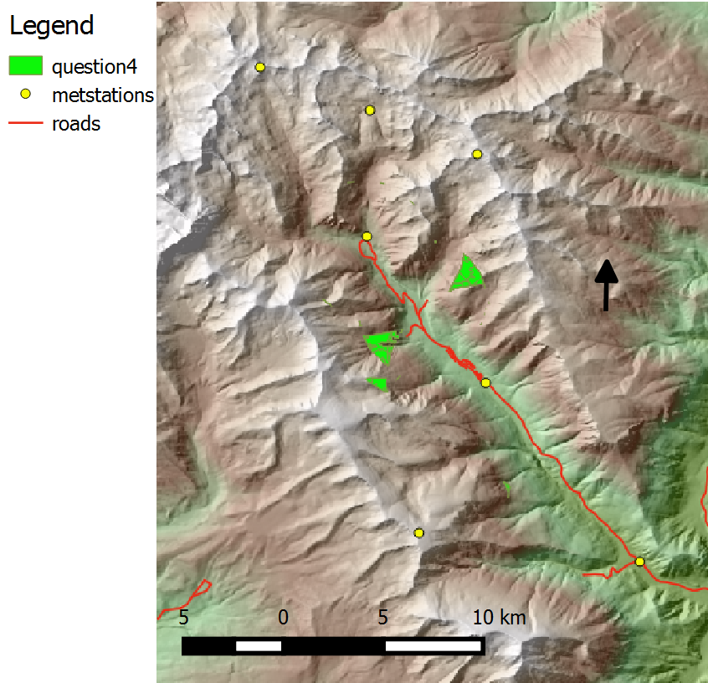

This map shows the areas which would best suit a new meteorological station to be placed. The areas were chosen given the guidelines that they are within 3 kilometres of the nearest road or piste, 5 kilometres from the nearest meteorological station and not in a forested area. I used buffers to determine areas which were inside the road/piste 3km buffer and outside the meteorological 5km buffer while also being outside of forested areas. I have deemed the four areas on the map to be the most suitable for a new meteorological station.